

**Asset Practice Questions: Mathematics**

1. Anil wants to find his weight. So he stands on a weighing machine, but along with the bag he is carrying. He soon realises his mistake and this time stands on the machine, without his bag.

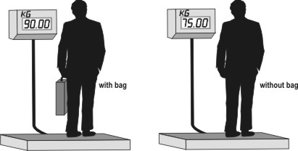

Clever Anil realises that the WEIGHT OF HIS BAG is

A. 15 kg.

B. 25 kg. C. 90 kg. D. 165 kg.

2. Shown here is the information about the entrance tickets to an exhibition.

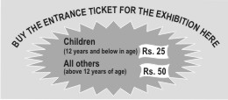

Some Class 4 students, all below 12 years of age, visit the exhibition. Which of these would be the correct way to calculate the amount of money they will have to spend on the tickets?

A. 12 x 25

B. number of students + 25

C. number of students x 25

D. number of students x 12 x 25

3. 1 apple and 2 oranges together weigh 330 grams. If each orange weighs 100 grams, how much does the apple weigh?

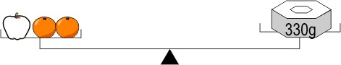

A. 30 grams

B. 100 grams

C. 110 grams

D. 130 grams

4. Manu had 5 spelling tests in a month. On each test, he scored 4 points more than the previous one.

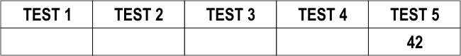

If he scored 42 points on Test 5, how much did he score on Test 1?

A. 26

B. 30

C. 38

D. 58

5. After a cricket match in the Twenty 20 World Cup, a newspaper reported ''10 sixes hit by India in their innings. There were 15 fours as well.''

How many runs did India score through sixes and fours together in that innings?

A. 25

B. 100

C. 120

D. 150

6. Chanda bought some sweets to distribute to 7 of her friends. After giving 4 sweets to each friend, only

2 sweets were left with Chanda. How many sweets did she buy?

A. 13

B. 26

C. 28

D. 30

7. Nishchita had 18 pencils. After she put an equal number of pencils in 3 boxes, 3 pencils were left with her. How many pencils did she put in each box?

A. 0

B. 5

C. 15

D. 20

8. Kunal has some marbles. Adit gives him 23 more. Now Kunal has 39 marbles. How many marbles did

Kunal start with?

A. 16

B. 23

C. 39

D. 62

9. There are 25 children in a class. Each child was asked to name his or her favourite chocolate. The result is shown in the chart here.

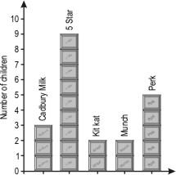

How many MORE children chose Perk than Cadbury Milk?

A. 8

B. 5

C. 3

D. 2

10. Some children voted for their favourite cartoon show. The number of votes received by different shows is shown in the table below.

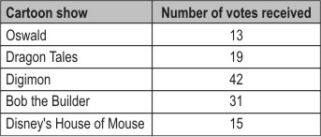

How many MORE votes did ''Bob the Builder'' receive than ''Dragon Tales''?

A. 12

B. 28

C. 31

D. 50

11. See the weighing shown below.

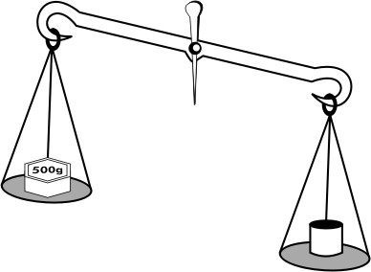

What could the weight of



be?

A. 1 kg B. 500 g C. 250 g D. 20 g

12. 25 children of a class went to the doctor for an eye check-up and were asked to read the letters from this chart:

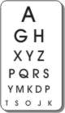

Study the chart and table to answer the question.

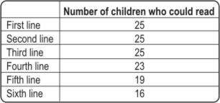

How many children in the class could NOT read the last line?

A. 11

B. 9

C. 6

D. 2